**Assignment 8.3 Advance Hive**

**Associated Data Files**

Link: <https://acadgild.com/blog/transactions-in-hive/>

**Problem Statement**

Link: <https://acadgild.com/blog/transactions-in-hive/>

Refer the above given link for transactions in Hive and implement the operations given in the blog using your own sample data set and send us the screenshot.

The below properties needs to be set appropriately **in hive shell** , order-wise to work with transactions in Hive:

set hive.support.concurrency = true;

set hive.enforce.bucketing = true;

set hive.exec.dynamic.partition.mode = nonstrict;

set hive.txn.manager = org.apache.hadoop.hive.ql.lockmgr.DbTxnManager;

set hive.compactor.initiator.on = true;

set hive.compactor.worker.threads = 1;

If the above properties are not set properly, the ‘Insert’ operation will work but ‘Update’ and ‘Delete’ will not work and you will receive the following error:

Creating a Table That Supports Hive Transactions

CREATE TABLE college1(clg_id int,clg_name string,clg_loc string) clustered by (clg_id) into 5 buckets stored as orc TBLPROPERTIES('transactional'='true');

ALTER TABLE college1 RENAME TO college;

INSERT INTO table college1 values (1,'nec','nlr'),(2,'vit','vlr'),(3,'srm','chen'),(4,'lpu','del'),(5,'stanford','uk'),(6,'JNTUA','atp'),(7,'cambridge','us');

select * from college1;

***Note:***

***In this table, we have bucketed the ‘clg_id’ column and performing the Update operation on the same column, so we have got the error. We can’t update the bucketed column.***

**Now let’s perform the update operation on Non bucketed column.**

**UPDATE college1 set clg_name = 'IIT' where clg_id = 6;**

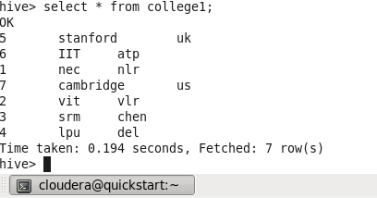

**delete from college1 where clg_id=5;**

